**Joseph Knight Family Connections to the 2025 Come Follow Me Lessons**

**Doctrine and Covenants 85:1-2, “Keep a history”**

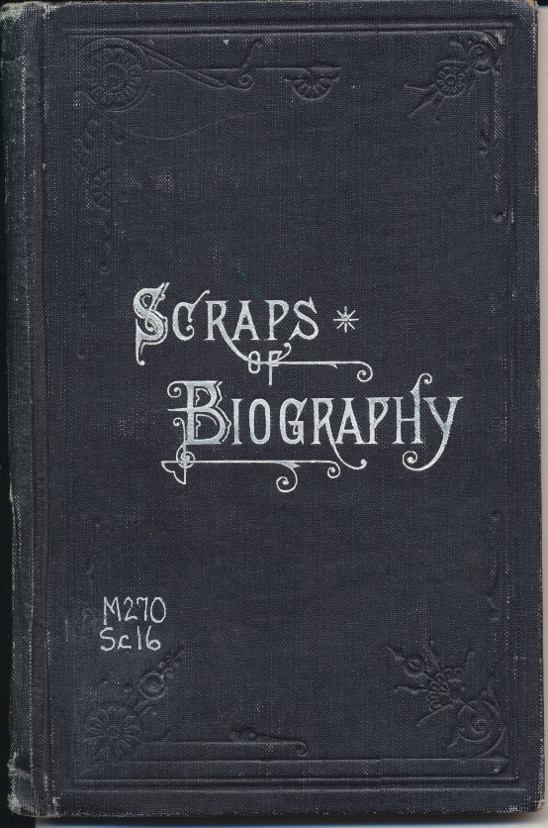 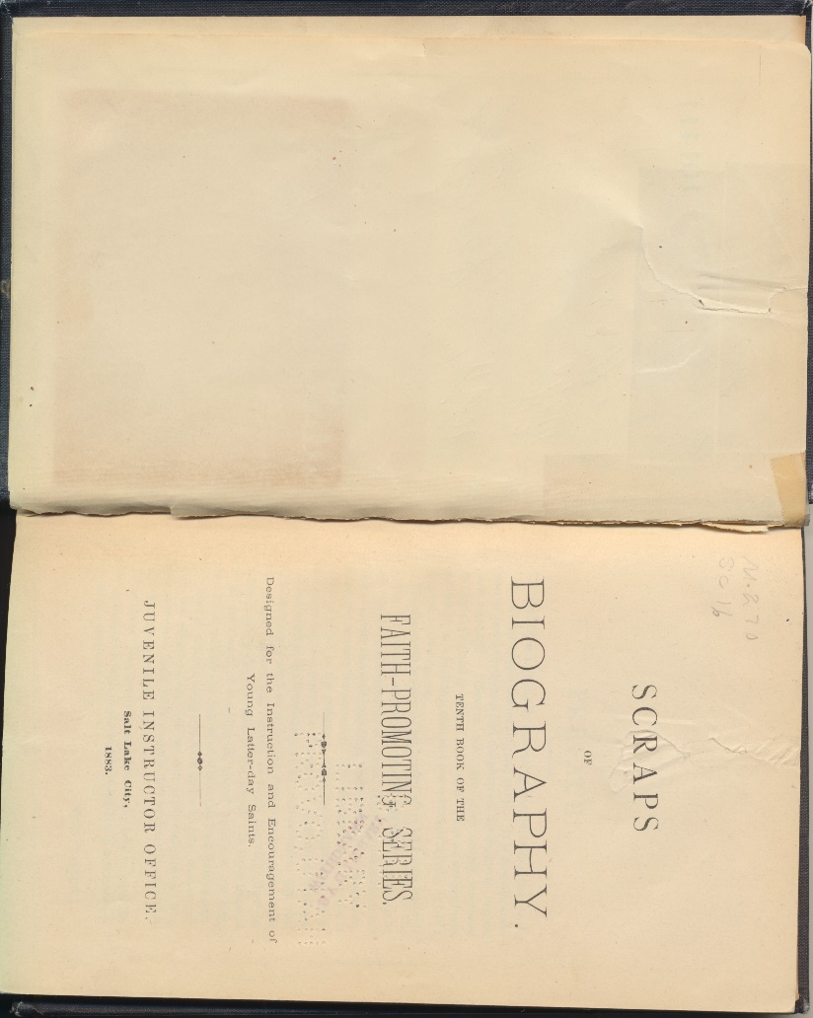

***About 50 pages from Newel Knight’s Journal are in this 1883 book, Scraps of Biography.***

**Knights who wrote histories**

One of the significant contributions to the Church that some the Knight family made was keeping a written history of their experiences. They were witnesses to many events in the restoration of the Gospel, and their records give more detail and depth to the events that transpired.

The commandment given in Section 85:1 in November of 1832 is directly specifically to the clerk of the church, W. W. Phelps who was living in Missouri and printing the Times and Seasons newspaper. He was told that as the clerk it was his duty to “keep a history and a general church record of all that transpired in Zion.” And verse 2 adds that the record should include “their manner of life, their faith, and works.”

The verse also mentions that the need to keep track of all who consecrate properties to the bishop and all those who receive inheritances, which probably refers to land leased to them. This consecration of property in Missouri is addressed in a separate article, “Joseph Knight, Jr.’s Missouri Deed,”

The four Knight family members who wrote their histories seem to embody the counsel of the scripture to include their manner of life, their faith and works as they wrote their stories.

**Joseph Knight, Sr.** wrote a ten-page handwritten manuscript that can be viewed in the Church History Library archives, call number MS 3470. Type Joseph Knight Reminiscences of Early Church History in the history library catalog search bar.

The catalog description of the content is:

Relates incidences concerning Joseph Smith's possession of the gold plates and their translation, and subsequent events in the early history of the Church. Incomplete.

Father Joseph writes with almost no punctuation and some random capitalization, sometimes making it a challenge to read. A transcription of his writing can be found in William G. Hartley’s book, *Stand By My Servant Joseph* in appendix A. It is worth reading. Father Knight gives some details about the coming forth of the Book of Mormon that are not found anywhere else.

**Joseph Knight, Jr.**

Joseph Knight, Jr. wrote part of his 6-page manuscript, “*Incidents of History, 1817 to 1844”* in 1862 in the Salt Lake Valley with the help of Thomas Bullock. The original copy is in the Church History Library archives, call number MS 286. This history is the most commonly cited source for the names of who the first six members of the church were.

The library catalog gives this description of his history.

Relates early association of his family with Joseph Smith in New York and describes retrieval of the gold plates, translation of the Book of Mormon, and the Knight family's baptism. Also tells of move to Kirtland, Ohio, and then Independence, Missouri, and settlement in Nauvoo, Illinois. Copy made in the Historian's Office by clerk Thomas Bullock and signed by Joseph Knight, Jr. Includes Bullock's annotation "Joseph Knight's incidents of history from 1827 to 1844. Compiled from loose sheets in J. K's possession, Augt. 16, 1862." Signed statement recounting of his 1831 settlement in Jackson County, Missouri, the consecration of his property to Edward Partridge, and his marriage to Betsy Covert. Recorded in Historian's Office by clerk Thomas Bullock, who also witnessed the document. Bears Bullock's annotation "First settlement in Jackson Co. 1st. Augt. 1831." Knight's signed statement affirms that Oliver Cowdery, Joseph Smith, Jr., Hyrum Smith, Peter Whitmer, Jr., Samuel H. Smith, and David Whitmer were the first members of the Church when it was organized on 6 April 1830 in Fayette, New York. Statement also affirms that Knight was given the information by Oliver Cowdery. Document recorded in Historian's Office by Robert L. Campbell, with George A. Smith, Robert L. Campbell, Thomas Bullock, and John V. Long as witnesses. Copy of stewardship agreement executed in Missouri between Joseph Knight, Jr. and Edward Partridge as bishop of the Church. Leases to Knight a parcel of land in Jackson County, Missouri, as well as personal property described in the document. Copy made 14 August 1862 by Historian's Office clerk Thomas Bullock from "original deed, in Jos. Knight's care." Bullock's clerical notation describes the document as a "lease of inheritance." The original 1832 deed has been cataloged as MS 5589 fd. 1.

**Newel Knight**

It appears that Newel wrote and rewrote his journal and autobiography over the course of about 15 years. Several different versions of his journal can be found. The first copy written in his own handwriting is 185 pages and is available to view online in the Church History Library archives.

That first copy of the journal for the most part is not a linear, day-to-day record of Newel’s experiences. It begins with an event in 1833, then goes back to memories in 1830 and so on. His autobiographical part doesn’t begin until page 33. It appears Newel was intent on recording his memories, but sat down to write about whatever came to mind. He probably intended to edit it later, but he passed away in 1847 in Nebraska before that could happen.

There are several other versions of his journal, and the best explanation of the various version is found in the introduction of the book by Michael Hubbard and William G. Hartley, *The Rise of the Latter-day Saints; the Journals and Histories of Newel Knight,* published by Deseret Book in 2019. Newel recorded many things on slips of paper, and some were lost. As he assisted Joseph Smith, Jr. in recording the Church history, he felt to use the things he recorded for Joseph in his own record, or he just made note that he was a part of events that were printed in the times and Seasons.

Newel’s wife Lydia also edited and recopied some of his journal. Some of what Lydia edited was published in the small book published in *Scraps of Biography, the Faith Promoting Series Book 10,* published by The Juvenile Instructor, 1883. Newel’s journal is on pages 46-101 in this small volume. A copy is not digitally available to view in the Church History library, but a paperback copy can be purchased from Amazon and several online book sellers for $7-15.

The Church History Library catalog has a digital copy of three versions of the Newel Knight journal and autobiography. All three versions are found with the library call number MS 767.

The first is 185 handwritten pages believed to be in Newel’s handwriting. The catalog description of this version reads:

Account of Knight's early association with Joseph Smith and his experiences in Colesville, New York; Jackson and Clay counties, Missouri; Kirtland, Ohio; Far West, Missouri; and Nauvoo, Illinois. Includes daily entries referring to his emigration west in 1846 and experiences in the George Miller company that wintered near the Ponca Indian settlements. Interjected into his early recollections are selections from the history of Joseph Smith as it was published in the Times and Seasons newspaper.

The second version of Newel’s journal in the Church History Library Archive is 254 handwritten pages. It has been edited and expanded.

The library catalog of the of manuscript is:

Account of Newel Knight's association with Joseph Smith and his experiences in New York, Ohio, and Missouri. Includes copy of journal entries for his activities in Nauvoo, Illinois; emigration west in 1846; and experiences in the George Miller company that wintered near the Ponca Indian settlements. Journal entries end just prior to Knight's death in January 1847. The first part of his recollections consists mostly of incidents that were excerpted from printed sources. Copyist for this version of Knight's autobiography is unknown.

The third is labeled “Autobiographical sketch,” is undated, and 32 handwritten pages.

The library catalog description is:

Brief synopsis of Knight's early association with Joseph Smith and his activities in Missouri; Kirtland, Ohio; and Nauvoo, Illinois.

Lydia Knight’s History was also published by the Juvenile Instructor, the youth publication for the church at the time, in 1883. The author is listed as “Homespun,” which was the pen name of Susa Young Gates. It appears that Gates interviewed Lydia to obtain her history. Lydia’s history can be found online at <https://readingroo.ms/4/6/6/0/46602/46602-h/46602-h.htm>. (Or just google Lydia Knight History.) Small paperback copies of Lydia’s history are also available online for purchase.

Diane Mangum – July 2025